Consumers expect top-notch broadband service at luxury hotels
The demand for high-speed broadband services is growing for customers and learning about the area, services, and infrastructure of broadband that is provided can give insight as to what rate and cost Hotels can provide Wi-Fi to their clients. High-speed internet access (Wi-Fi) is provided now in almost every hotel, but the main challenge for hoteliers has been to offer guests the same level of broadband service in a hotel room as they receive at home, in terms of speed, reliability and security. Hotels must also allow guests to access Wi-Fi in all hotel areas—in the lobby, in a room or at the pool or fitness center. Out of all business travelers, ninety-five percent care if there are Wi-Fi services or wired connections at the hotel. Sixty-three percent of these business travelers confirm whether a hotel has broadband services before booking. Thirty-five percent of these business travelers would pay for a faster connection and seventy-nine percent return to the same locations on business trips. However, if broadband services fail to meet consumer needs, twenty-five percent of these visitors say they may never return.

Benefits of high-speed broadband
There are several benefits to improving a hotel’s broadband internet access: Improves demand for services and customers’ willingness to pay; Improves company structure and communication; Increased benefit of internet and applications provided by the internet. Some hotels like Marriott are now charging extra for faster Wi-Fi (Fig. 1).

Committing to infrastructure renovation
The challenge of maintaining a hotel is deciding not only what features need renovation, but how frequently changes need to be made. Some hotels demand renovations with greater frequency than others, depending on the expectations of the customers the short operational lifespan of technology in the twenty-first century. Wireless and broadband technology has a high development rate; hoteliers cannot afford to lag behind Wi-Fi technology, or they will lose customers. However, powering the devices that access a hotel’s broadband network has become almost important as the network itself. A convenient power source should be an obvious technological upgrade to a hotel room, but a surprising number of guests complain about diving under a desk or moving furniture just to gain access to a power outlet. International luxury hotels, especially those located outside large cities, are frequently “under powered,” forcing guests to charge phones, iPads and other Wi-Fi enabled devices in the hotel lobby or business center. Smart hoteliers see the connection between sources of power and a wider broadband network, and provide their guests with recharging and powering capability throughout a property.

Three broadband infrastructure rollout scenarios
When a hotel commits to improving its Wi-Fi network, it can do so using one of the following three industry related rollout scenarios. An Unsubsidized Rollout scenario is usually completed without government subsidies: this scenario allows hotel patrons to access high speed broadband over ninety-three percent of the time. A Multi-Technology Mix scenario, also known as the MTM scenario, is the rollout of high speed broadband through the use of multiple technologies. Finally, a Fiber or FTTP rollout scenario allows hotels to upgrade their copper cables to fiber optic cables.

Of the three scenarios, the FTTP scenario provided the highest rate of upload speeds (measured in Mbps), with the MTM scenario following second, the unsubsidized scenario following third. Nearly all data supports our conclusion that fiber optic cable offers the best method of delivering broadband Wi-Fi to hotel guests.

Implementation time and overall cost of each rollout scenario
The FTTP rollout scenario takes longer and brings higher incremental costs than the MTM or Unsubsidized Rollout scenarios, since replacing copper cables with a fiber optic network requires extensive construction, rewiring and remodeling. The MTM rollout scenario has lower initial costs compared to the FTTP scenario but higher costs over time; these costs fluctuate depending on wireless and satellite provider rates. An Unsubsidized Rollout provides upgrades to the existing speeds, and costs less and takes less time, but does not offer patrons as fast a service as the FTTP and MTM scenarios. Choosing a scenario has become increasingly important: as figure 2 indicates, Google is actively developing fiber networks in 34 US cities.

Fig. 1: The notification for Marriott’s Enhanced High Speed network.
Fig 2.: Cities with Google’s Fiber (green: current cities; red: projected cities.

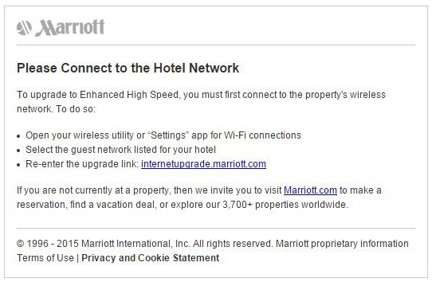

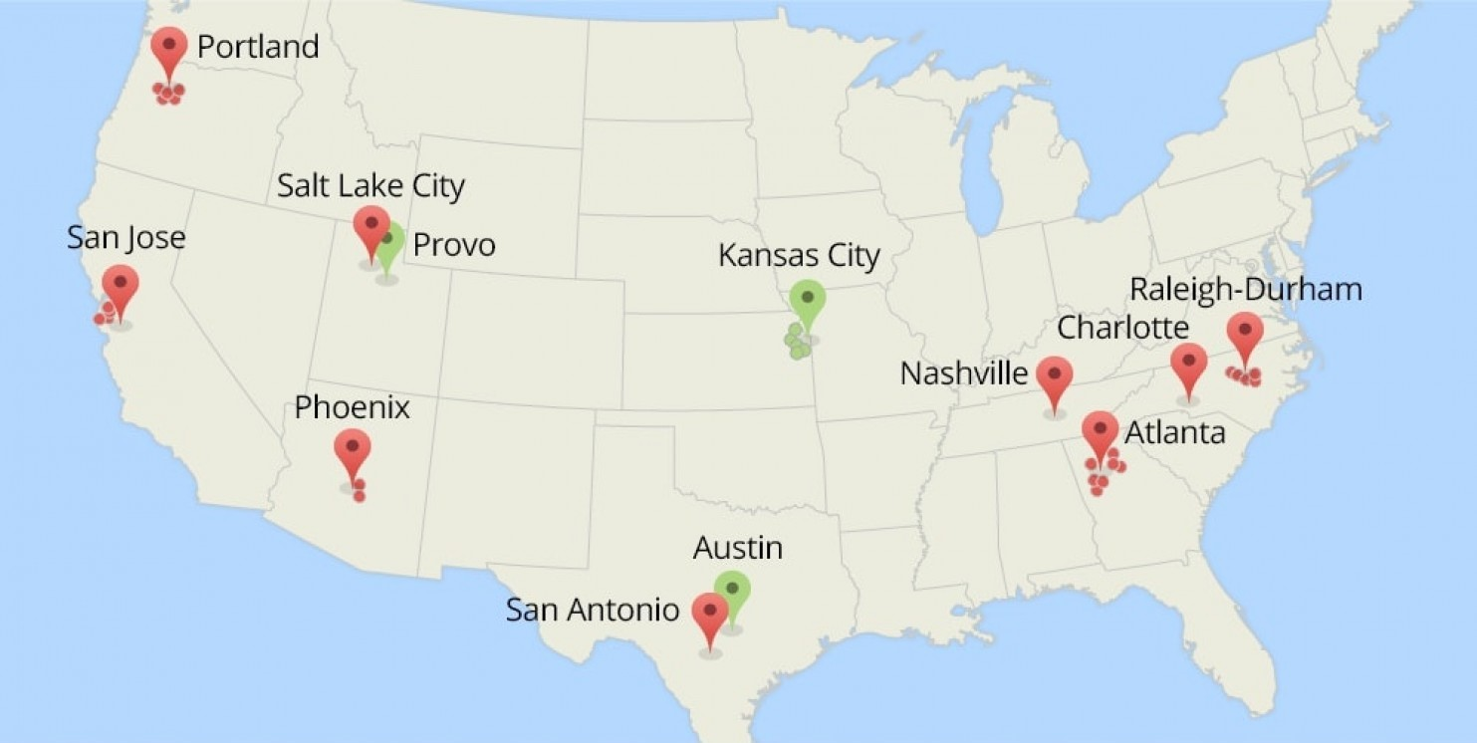

Johnson, Carla. (Fall 2014). “Broadband Access in Luxury Hotels.” Hotelier 23:3. 23-31.
Sherman, E. (May 3, 2015) Why are these luxury hotels still charging for Wi-Fi? Fortune. Retrieved from http://fortune.com/2015/05/03/luxury-hotels-wifi/ on April 10, 2016.
Fung, B. (February 29, 2014). Map: The 34 cities that may be awarded Google Fiber by year’s end. Washington Post. Retrieved from https://www.washingtonpost.com/news/the-switch/wp/2014/02/19/map-the-34-cities-that-may-be-awarded-google-fiber-by-years-end/ on April 10, 2016.

